ABC’s Inventory Management System

Manage Staff (Update Staff) Test Scripts

Table of Contents

UST001- Enter all details while updating staff details 3

Data Set 1 3

UST002- Leave a few details empty while updating staff details [BUG UST1] 6

Data Set 1 6

UST003- Leave a few details empty while updating staff details [Bug Fix: BUG UST1] 8

Data Set 1 9

UST004- Change password of a user by entering all required data 12

Data Set 1 12

UST005- Change password of a user by entering password values that do not match 15

Data Set 1 15

UST006- Click on ‘Cancel’ icon after changing details 18

Data Set 1 18

# UST001- Enter all details while updating staff details

|  |  |  |  |  |  |
| --- | --- | --- | --- | --- | --- |
| **Test Name** | | Test enter all details while updating staff details (Test UST001) | | | |
| **Use Case Tested** | | Manage Staff | | | |
| **Test Description** | | This test tests if staff details can be updated when all details are entered. | | | |
| **Pre-Conditions** | | Users need be logged in as a Warehouse Staff (Warehouse Staff Access) in the Manage Staff page | | | |
| **Post-Conditions** | | Appropriate message is displayed  Staff details are updated | | | |
| **Result (Pass/Fail/Warning/ Incomplete)** | | Pass | | | |
|  | **Test Step** | | **Expected Test Results** | **P** | **F** |
| 1. | Click on ‘Update’ icon on the staff that needs to be updated on the Manage Staff page. | | System displays the details of the staff selected and waits for user to change any details required (except for username) and click on the ‘Confirm Update’ icon | P |  |
| 2. | Enter all necessary changes and click on the ‘Confirm Update’ icon. | | System displays appropriate message. | P |  |
| 3. | User clicks on ‘OK’ | | System displays the Manage Staff page with staff with updated details. | P |  |

## Data Set 1

|  |  |
| --- | --- |
| **Data Set 1** | |
| **Field** | **Values** |
| **Username** | mark |
| **First Name** | Mark |
| **Last Name** | Ferguson |
| **Location** | Epping Store |
| **Contact** | 2398133 |
| **Date of Birth** | 23/01/1995 |
| **Address** | 23 Manor Drive, Hornsby, NSW 2077 |
| **Email** | markf@email.com |

**Step 1**

System displays the details of the staff that needs to be updated allowing user to change it.

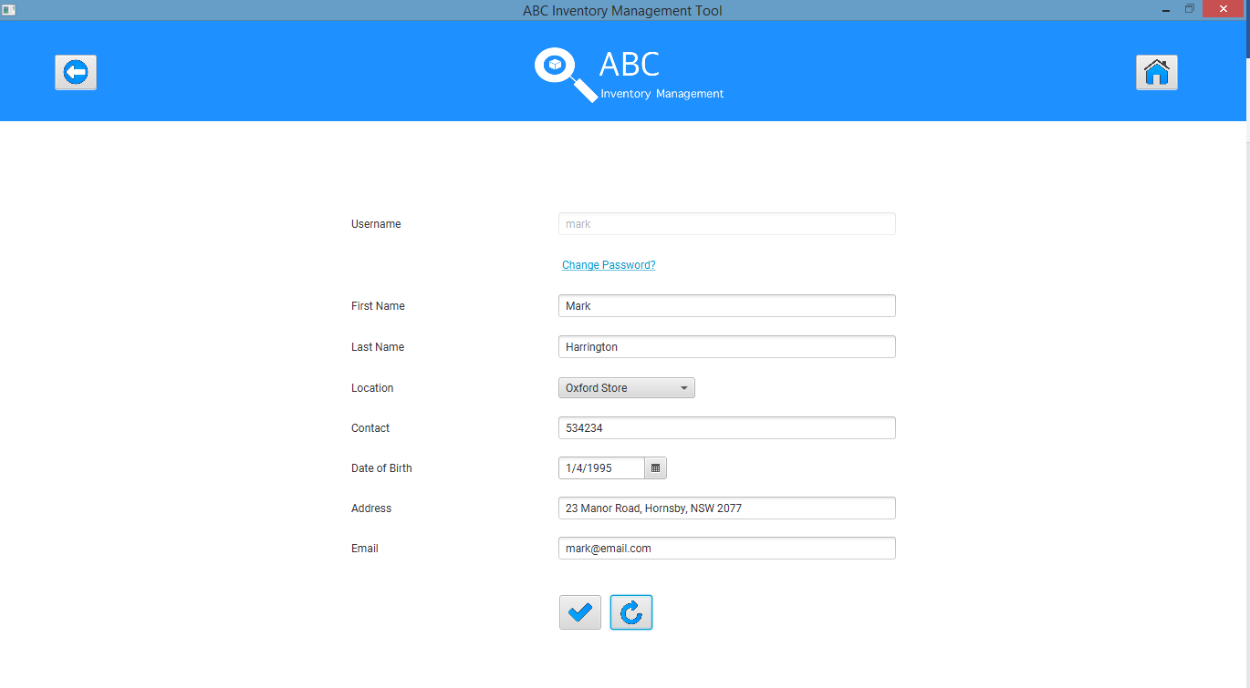

**Step 2**

Change the details that needs to be updated.

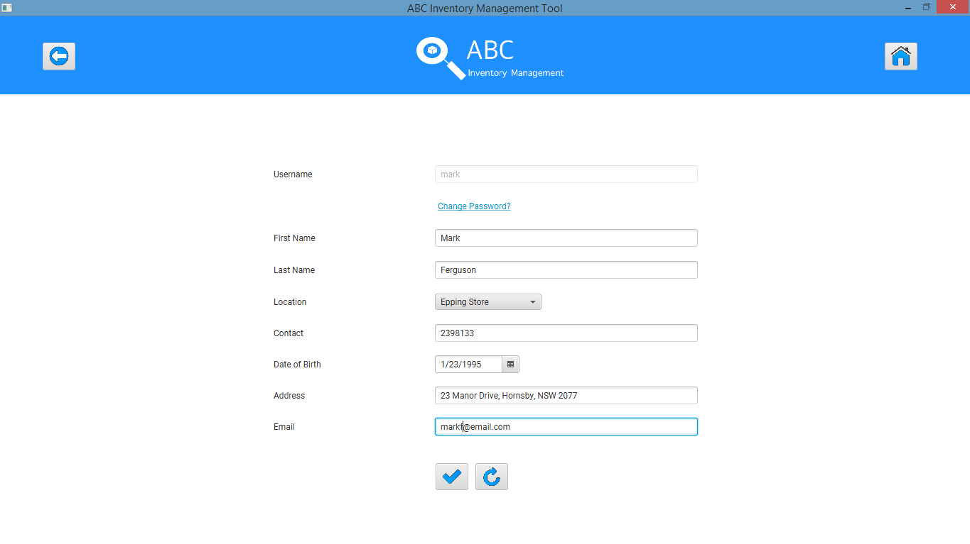

**Step 3**

Click on ‘Confirm Update’ icon after which the system displays an appropriate message.

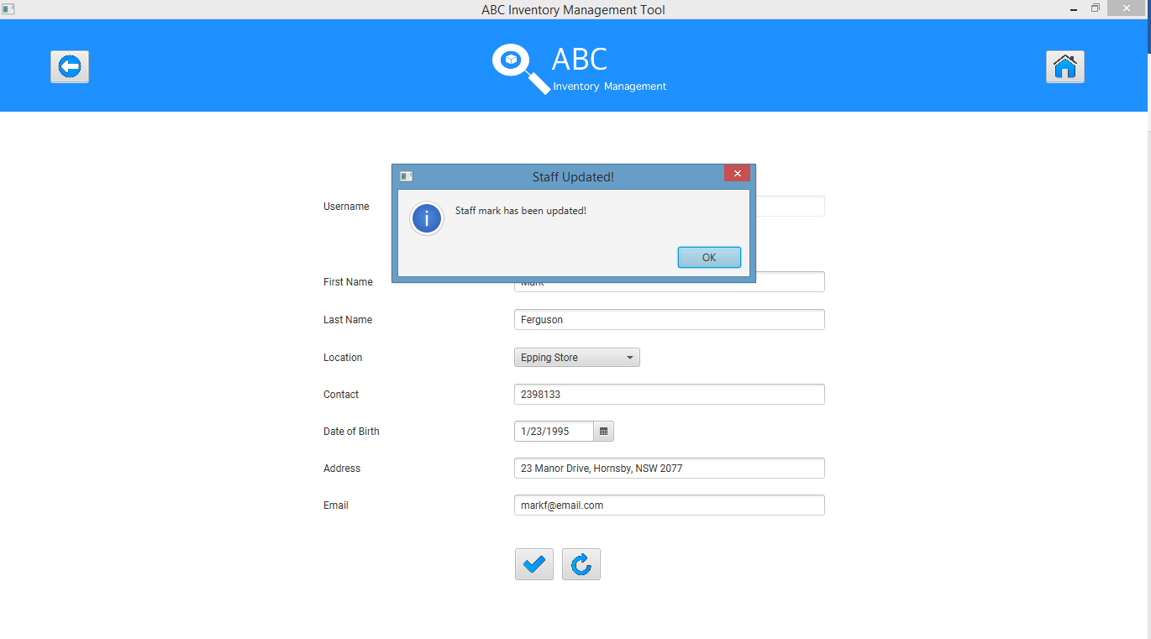

**Step 4**

System displays the ‘Manage Staff’ icon after the user clicks on ‘OK’

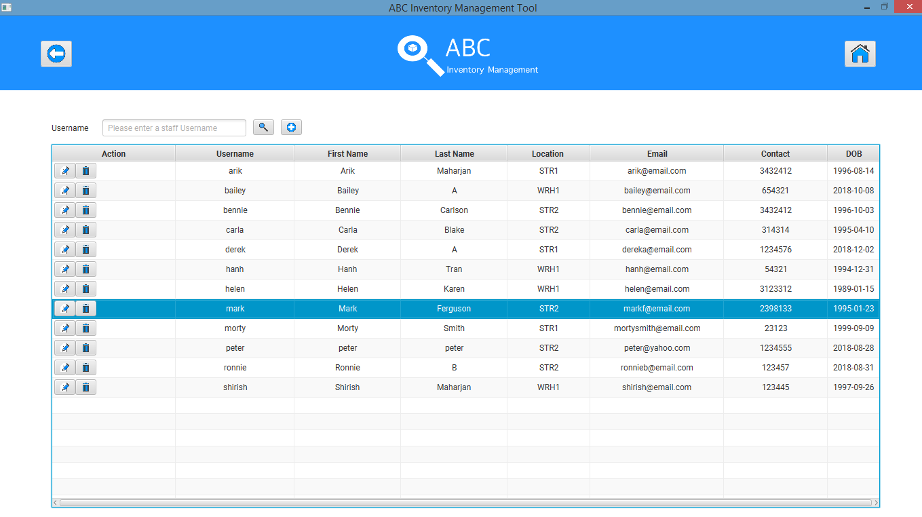

# UST002- Leave a few details empty while updating staff details [BUG UST1]

|  |  |  |  |  |  |
| --- | --- | --- | --- | --- | --- |
| **Test Name** | | Test leave a few details empty while updating staff details (Test UST002) | | | |
| **Use Case Tested** | | Manage Staff | | | |
| **Test Description** | | This test tests if staff details can be updated when some details are skipped while updating staff. | | | |
| **Pre-Conditions** | | Users need be logged in as a Warehouse Staff (Warehouse Staff Access) in the Manage Staff page | | | |
| **Post-Conditions** | | Appropriate message is displayed prompting user to enter all required fields. | | | |
| **Result (Pass/Fail/Warning/ Incomplete)** | | Fail | | | |
|  | **Test Step** | | **Expected Test Results** | **P** | **F** |
| 1. | Click on ‘Update’ icon on the staff that needs to be updated on the Manage Staff page. | | System displays the details of the staff selected and waits for user to change any details required (except for username) and click on the ‘Confirm Update’ icon | P |  |
| 2. | Enter all fields except for Last Name, Contact and Email Address and click on the ‘Confirm Update’ icon. | | System displays appropriate message prompting user to enter all required fields. |  | F |
| 3. | User clicks on ‘OK’ | | System highlights the fields that are required. |  | F |

## Data Set 1

|  |  |
| --- | --- |
| **Data Set 1** | |
| **Field** | **Values** |
| **Username** | carla |
| **First Name** | Carla |
| **Last Name** |  |
| **Location** | Epping Store |
| **Contact** |  |
| **Date of Birth** | 10/04/1995 |
| **Address** | 41 Batman Lane, Darlinghurst, NSW 2022 |
| **Email** |  |

**Step 1**

System displays the details of the staff that needs to be updated allowing user to change it.

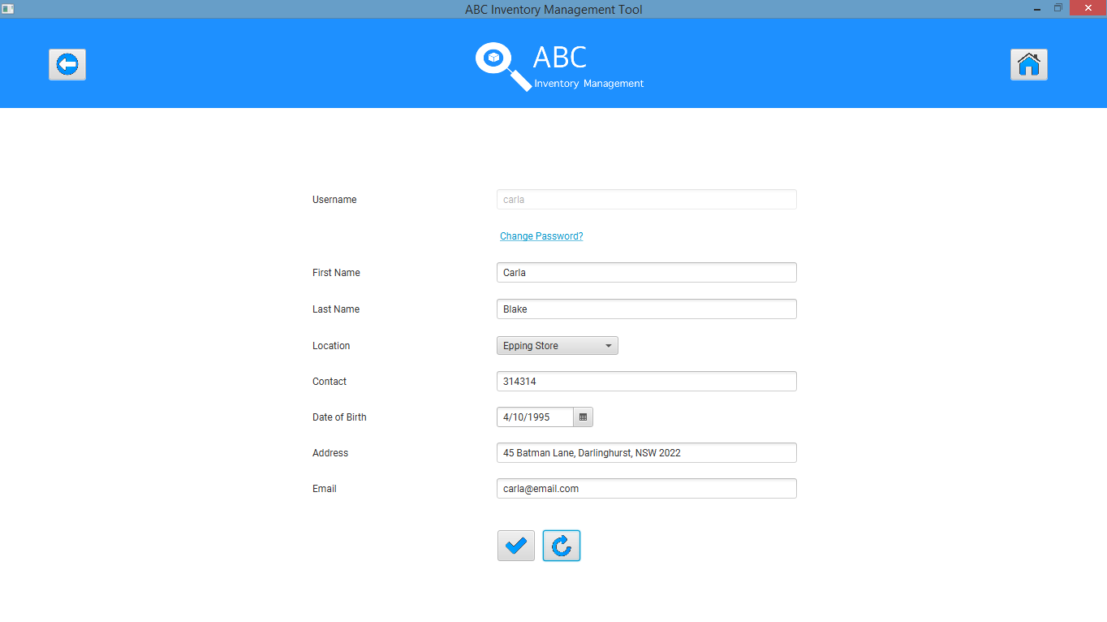

**Step 2**

Change the details that needs to be updated.

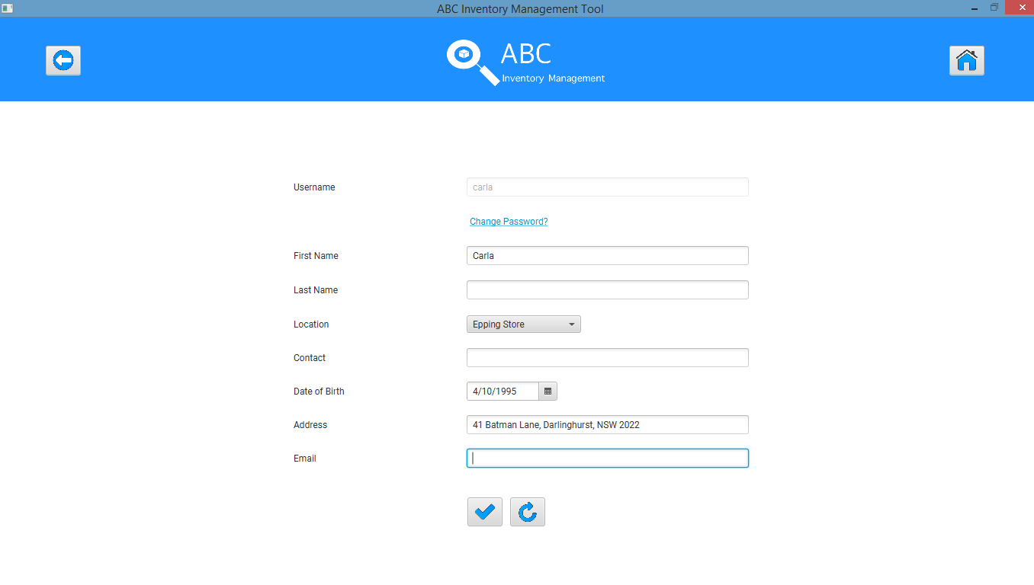

**Step 3 [Bug Found]**

Expected: System displays an error message prompting user to enter all required details.

Actual: Staff is updated

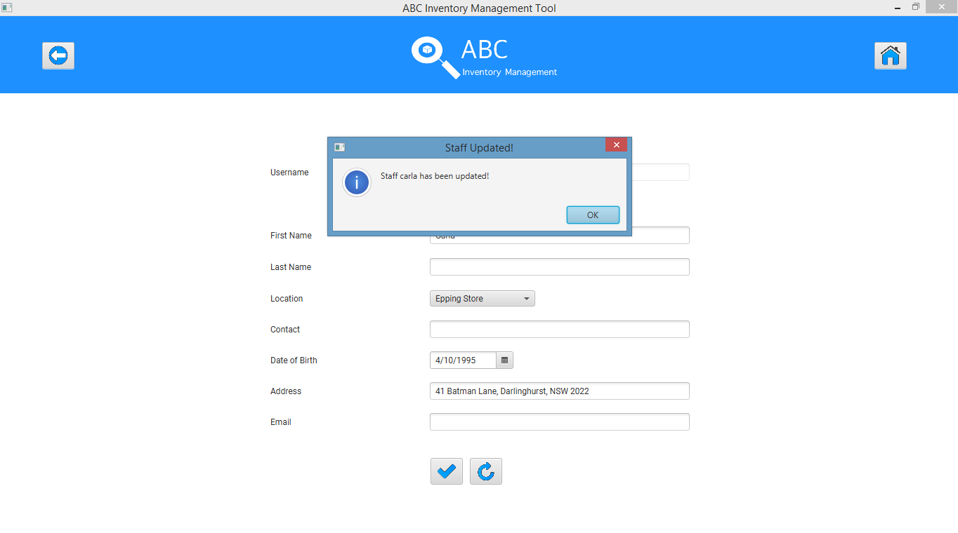

# UST003- Leave a few details empty while updating staff details [Bug Fix: BUG UST1]

|  |  |  |  |  |  |
| --- | --- | --- | --- | --- | --- |
| **Test Name** | | Test leave a few details empty while updating staff details (Test UST003) | | | |
| **Use Case Tested** | | Manage Staff | | | |
| **Test Description** | | This test tests if staff details can be updated when some details are skipped while updating staff. | | | |
| **Pre-Conditions** | | Users need be logged in as a Warehouse Staff (Warehouse Staff Access) in the Manage Staff page | | | |
| **Post-Conditions** | | Appropriate message is displayed prompting user to enter all required fields. | | | |
| **Result (Pass/Fail/Warning/ Incomplete)** | | Pass | | | |
|  | **Test Step** | | **Expected Test Results** | **P** | **F** |
| 1. | Click on ‘Update’ icon on the staff that needs to be updated on the Manage Staff page. | | System displays the details of the staff selected and waits for user to change any details required (except for username) and click on the ‘Confirm Update’ icon | P |  |
| 2. | Enter all fields except for Last Name, Contact and Email Address and click on the ‘Confirm Update’ icon. | | System displays appropriate message prompting user to enter all required fields. | P |  |
| 3. | User clicks on ‘OK’ | | System highlights the fields that are required. | P |  |

## Data Set 1

|  |  |
| --- | --- |
| **Data Set 1** | |
| **Field** | **Values** |
| **Username** | morty |
| **First Name** | Morty |
| **Last Name** |  |
| **Location** | Epping Store |
| **Contact** |  |
| **Date of Birth** | 08/09/1997 |
| **Address** | 42 Batman Lane, Darlinghurst, NSW 2022 |
| **Email** |  |

**Step 1**

System displays the details of the staff that needs to be updated allowing user to change it.

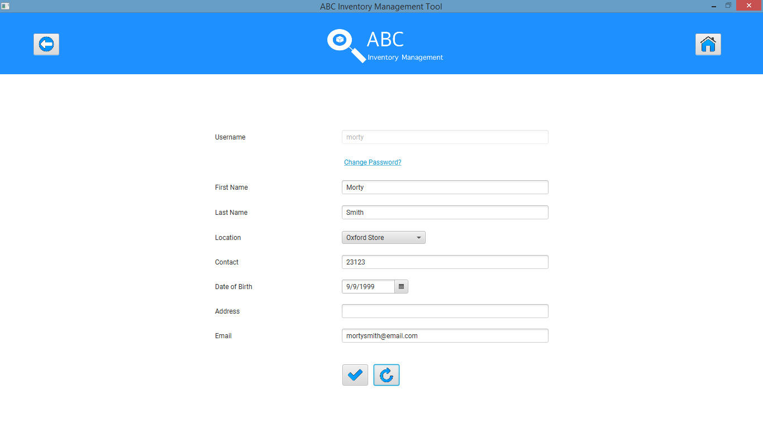

**Step 2**

Change the details that needs to be updated.

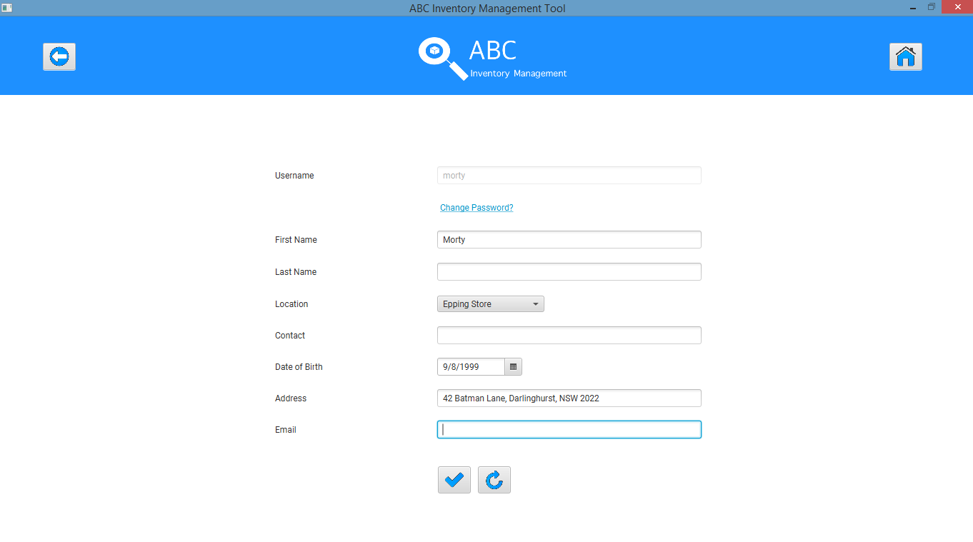

**Step 3**

System displays an error message prompting user to enter all required details.

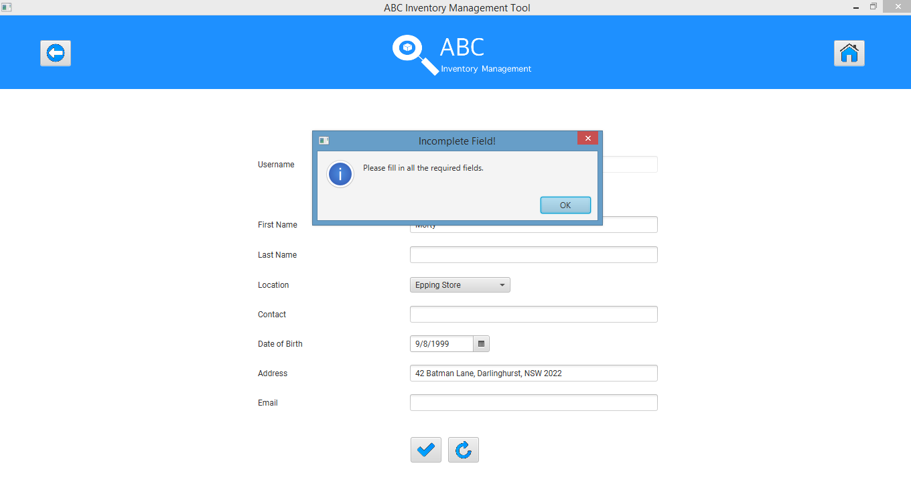

**Step 4**

System highlights the details that need to be entered.

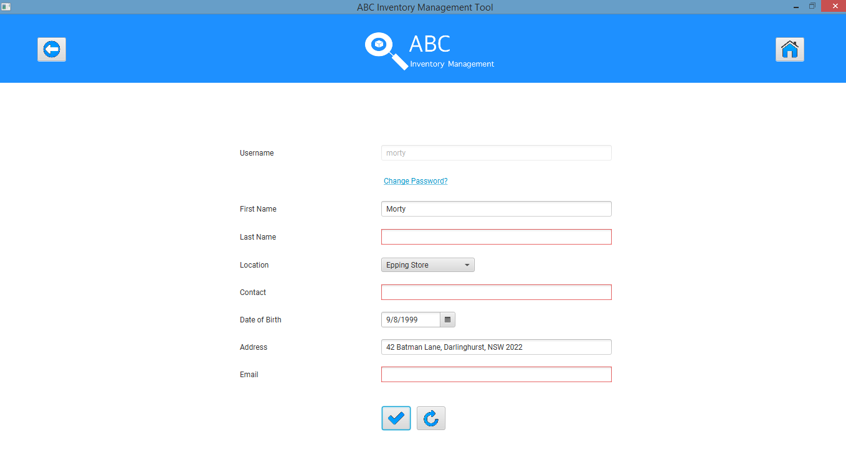

# UST004- Change password of a user by entering all required data

|  |  |  |  |  |  |
| --- | --- | --- | --- | --- | --- |
| **Test Name** | | Test change password of a user by entering all required data (Test UST004) | | | |
| **Use Case Tested** | | Manage Staff | | | |
| **Test Description** | | This test tests if a staff’s password can be changed. | | | |
| **Pre-Conditions** | | Users need be logged in as a Warehouse Staff (Warehouse Staff Access) in the Manage Staff page | | | |
| **Post-Conditions** | | Password is changed | | | |
| **Result (Pass/Fail/Warning/ Incomplete)** | | Pass | | | |
|  | **Test Step** | | **Expected Test Results** | **P** | **F** |
| 1. | Click on ‘Update’ icon on the staff that needs to be updated on the Manage Staff page. | | System displays the details of the staff selected and waits for user to change any details required (except for username) and click on the ‘Confirm Update’ icon | P |  |
| 2. | User clicks on ‘Change Password?’ link | | System displays the change password dialog box and prompts the user to enter the new password. | P |  |
| 3. | User enters the new password twice to confirm. | | System makes the ‘Update’ button clickable as soon as both fields have some value and waits for the user to click on the ‘Update’ button. | P |  |
| 4. | User clicks on the ‘Update’ button. | | System updates the password and displays an appropriate message. | P |  |

## Data Set 1

|  |  |
| --- | --- |
| **Data Set 1** | |
| **Field** | **Values** |
| **Password** | helenkaren |
| **Confirm Password** | helenkaren |

**Step 1**

System displays the details of the staff that needs to be updated allowing user to change it.

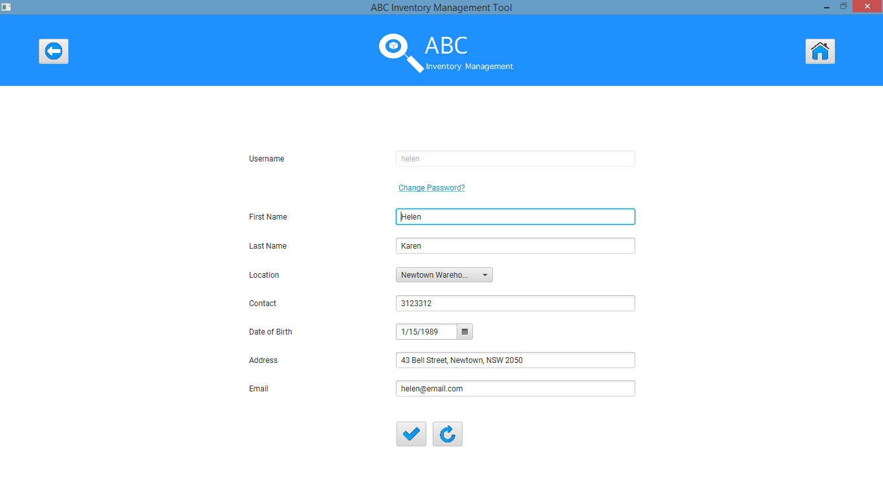

**Step 2**

User enters ‘Change Password?’ link after which the change password dialog box is opened.

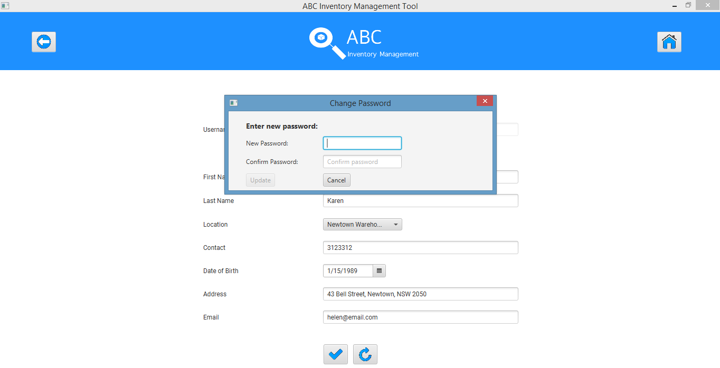

**Step 3**

User enters the new password twice to confirm.

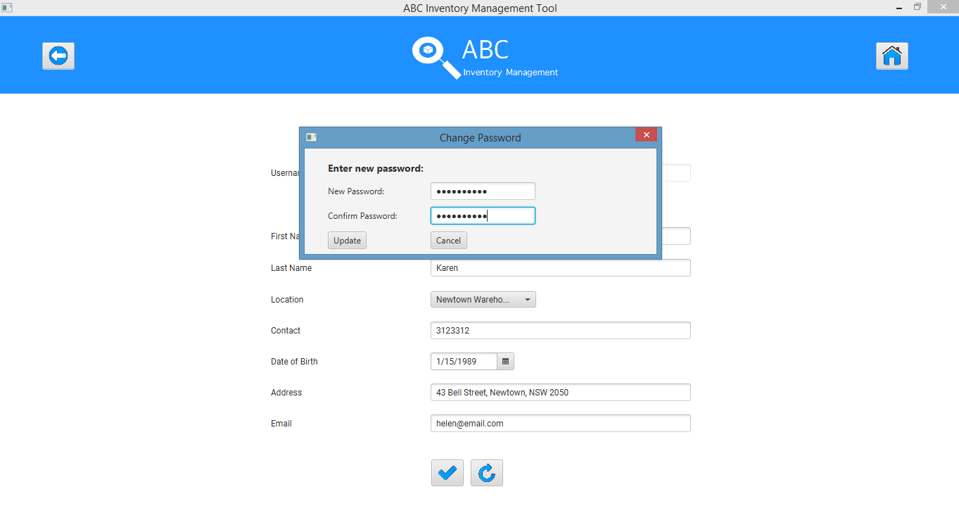

**Step 4**

System updates the password and displays an appropriate message.

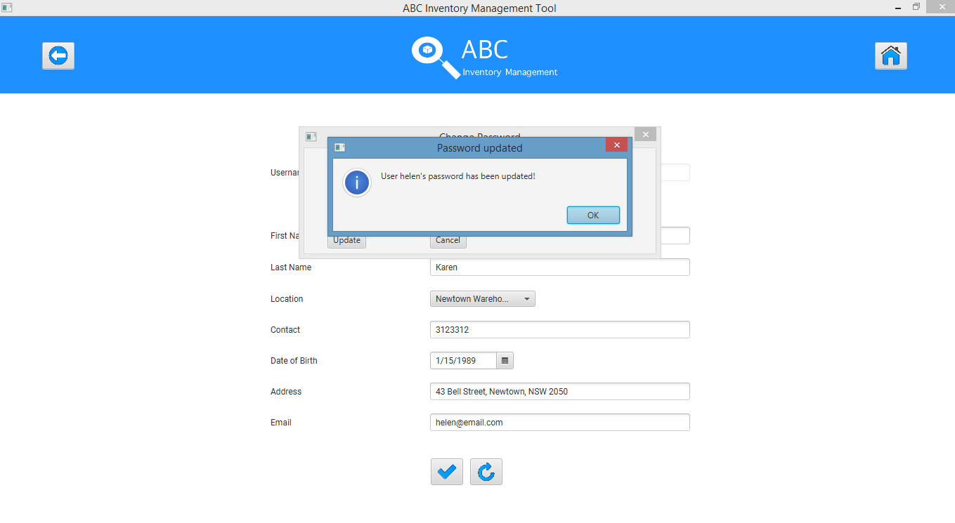

# UST005- Change password of a user by entering password values that do not match

|  |  |  |  |  |  |
| --- | --- | --- | --- | --- | --- |
| **Test Name** | | Test change password of a user by entering password values that do not match (Test UST005) | | | |
| **Use Case Tested** | | Manage Staff | | | |
| **Test Description** | | This test tests if a staff’s password can be changed when unmatched password values are entered. | | | |
| **Pre-Conditions** | | Users need be logged in as a Warehouse Staff (Warehouse Staff Access) in the Manage Staff page | | | |
| **Post-Conditions** | | Appropriate error message is displayed, and the system prompts the user to enter matching passwords. | | | |
| **Result (Pass/Fail/Warning/ Incomplete)** | | Pass | | | |
|  | **Test Step** | | **Expected Test Results** | **P** | **F** |
| 1. | Click on ‘Update’ icon on the staff that needs to be updated on the Manage Staff page. | | System displays the details of the staff selected and waits for user to change any details required (except for username) and click on the ‘Confirm Update’ icon | P |  |
| 2. | User clicks on ‘Change Password?’ link | | System displays the change password dialog box and prompts the user to enter the new password. | P |  |
| 3. | User enters passwords value that do not match. | | System makes the ‘Update’ button clickable as soon as both fields have some value and waits for the user to click on the ‘Update’ button. | P |  |
| 4. | User clicks on the ‘Update’ button. | | System displays and error message and prompts the user to enter matching passwords. | P |  |

## Data Set 1

|  |  |
| --- | --- |
| **Data Set 1** | |
| **Field** | **Values** |
| **Password** | helenkaren |
| **Confirm Password** | helenkarenn |

**Step 1**

System displays the details of the staff that needs to be updated allowing user to change it.



**Step 2**

User enters ‘Change Password?’ link after which the change password dialog box is opened.



**Step 3**

User enters password values that do not match.

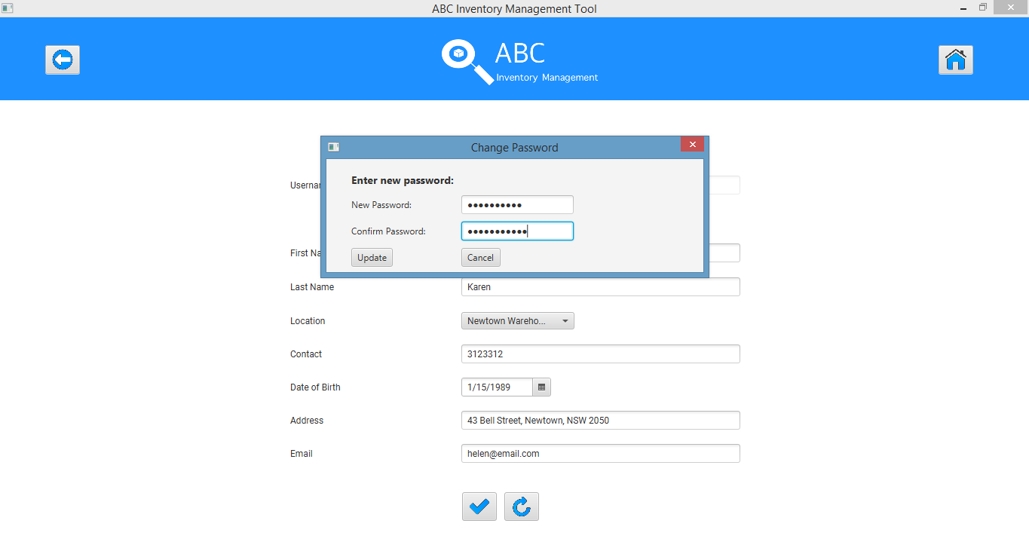

**Step 4**

System displays an appropriate message an prompts user to re enter matching passwords.

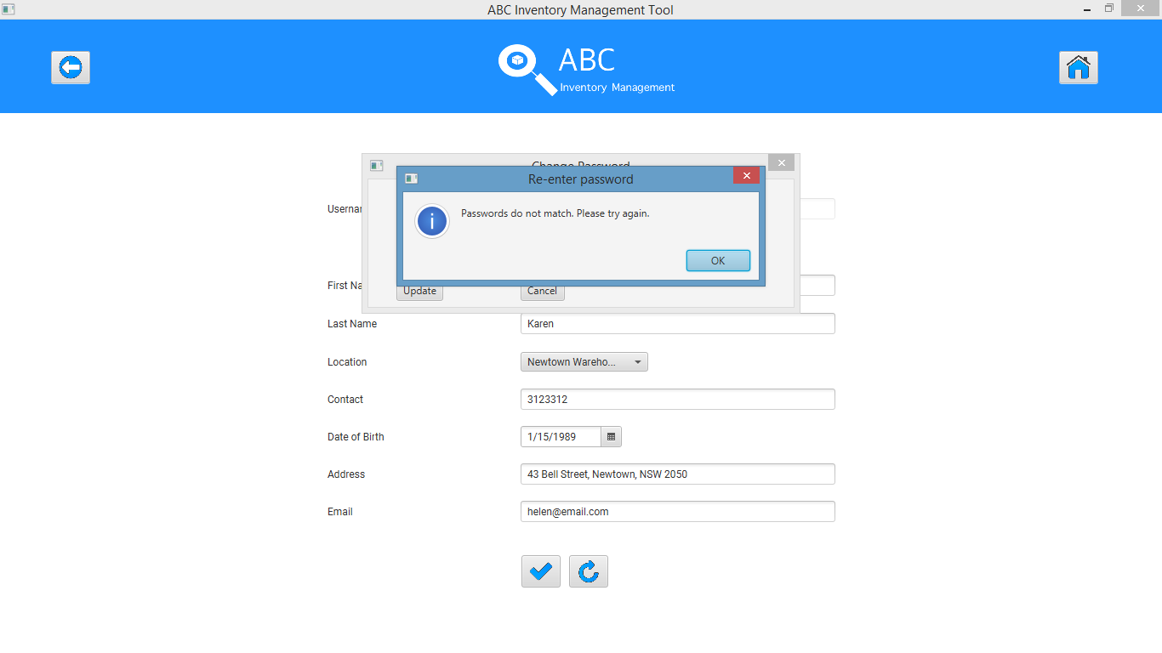

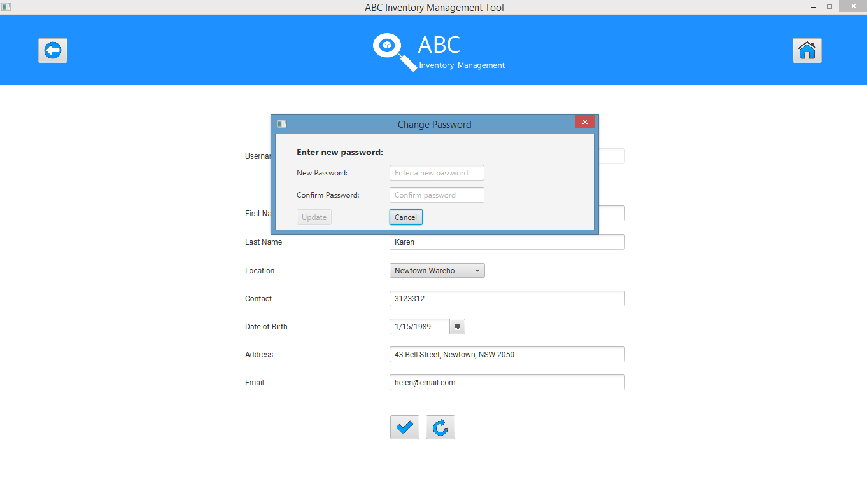

# UST006- Click on ‘Cancel’ icon after changing details

|  |  |  |  |  |  |
| --- | --- | --- | --- | --- | --- |
| **Test Name** | | Test click on ‘Cancel’ icon after changing details (Test UST006) | | | |
| **Use Case Tested** | | Manage Staff | | | |
| **Test Description** | | This test tests how the system reacts when the user clicks on ‘Cancel’ icon after making changes to the details | | | |
| **Pre-Conditions** | | Users need be logged in as a Warehouse Staff (Warehouse Staff Access) in the Manage Staff page | | | |
| **Post-Conditions** | | Details changed back to the original values. | | | |
| **Result (Pass/Fail/Warning/ Incomplete)** | | Pass | | | |
|  | **Test Step** | | **Expected Test Results** | **P** | **F** |
| 1. | Click on ‘Update’ icon on the staff that needs to be updated on the Manage Staff page. | | System displays the details of the staff selected and waits for user to change any details required (except for username). | P |  |
| 2. | Enter all necessary changes and click on the ‘Cancel’ Icon. | | System changes the details back to the original values. | P |  |

## Data Set 1

|  |  |
| --- | --- |
| **Data Set 1** | |
| **Field** | **Values** |
| **Username** | arik |
| **First Name** | Riko |
| **Last Name** | Federiko |
| **Location** | Epping Store |
| **Contact** | TEST |
| **Date of Birth** | 23/01/1995 |
| **Address** | TEST |
| **Email** | TEST |

**Step 1**

System displays the details of the staff that needs to be updated allowing user to change it.

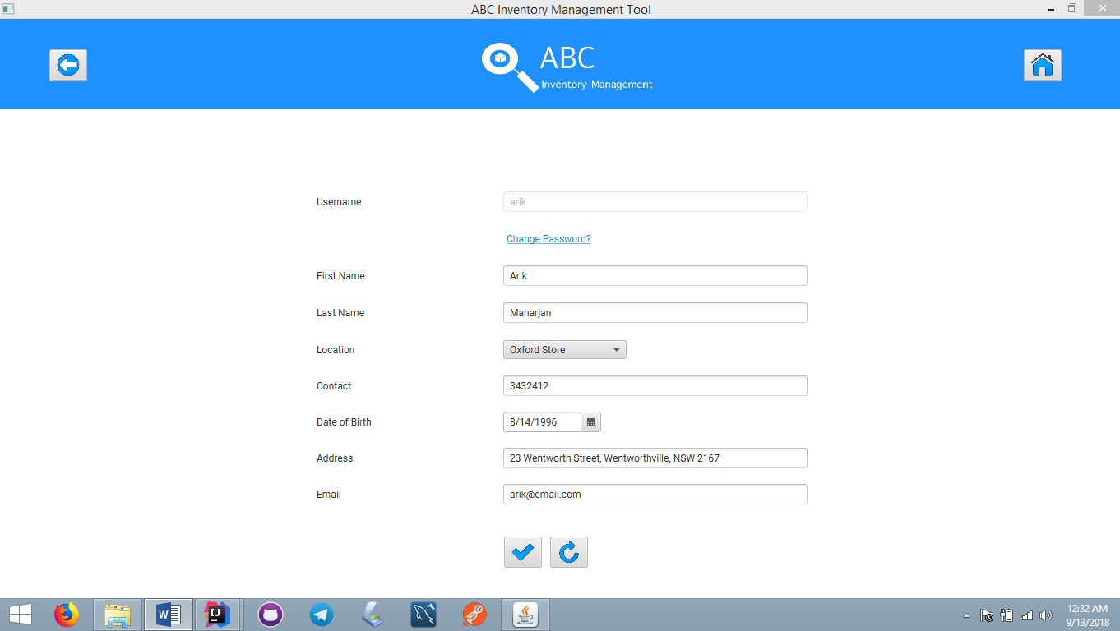

**Step 2**

Make necessary changes.

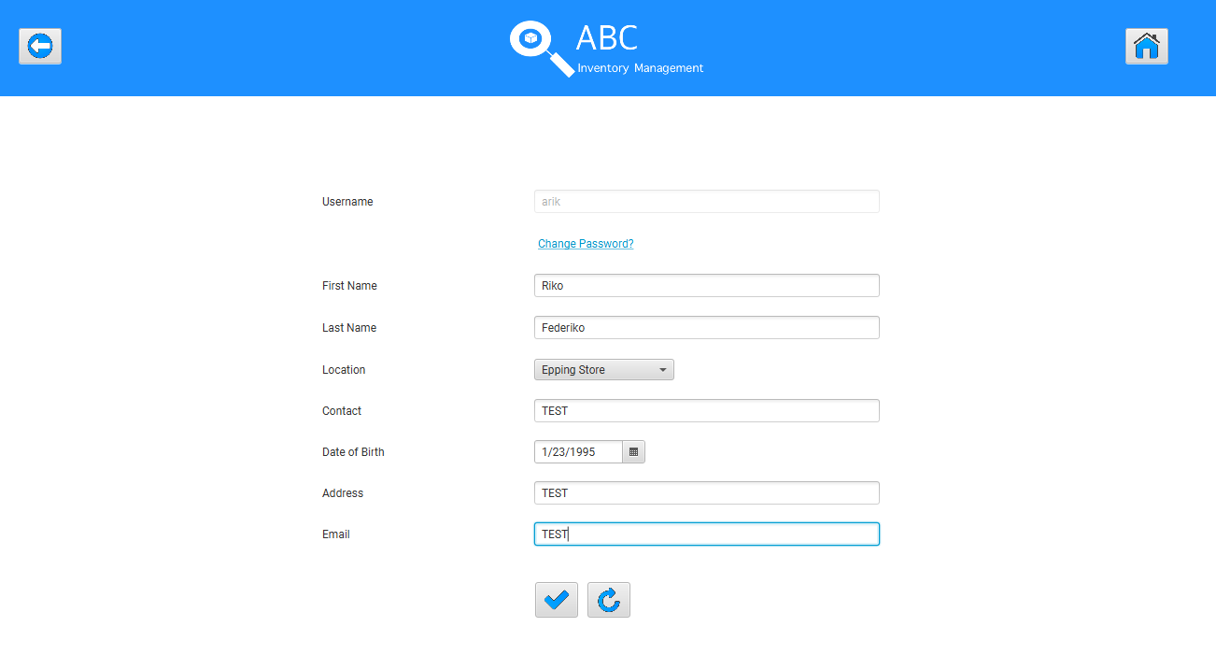

**Step 3**

After clicking on the ‘Cancel’ Icon, the system changes the changed data to its original value.

